Wooster Athletics-Handout

Athletic Physicals (Valid for 1 yr):

## Come to Wooster’s Clearance Night on 5/29 $25.00 Large Gym

## Visit your Family Physician

* Visit CHA-Community Health Alliance

## Visit HAWC-Health Access/Health Alliance

## Renown Urgent Care -Appointments 775.982-4100

* Visit Walmart, CVS, Walgreens

## 

How do I participate in Wooster Athletics?

* Be Enrolled or Sports Only at Wooster High School
* Must be cleared BEFORE TRYOUTS
* Complete *Register My Athlete* (15-20 min)

([www.registermyathlete.com](http://www.registermyathlete.com)) ALL ATHLETES MUST BE REGISTERED IN RMA/AKTIVATE

* Have a current Athletic Physical (valid for one year)
* Pay athletic fees once every school year to Wooster Bookkeeper (Scarlett Garzon)
* Have a Current ImPACT test (administered by Athletic Department)

$100 Athletic Fee: WHS ONLY

* $50 Transportation Fee (1 time annual fee)
* $50.00 Green fee-Golf only
* $25 Activity Fee (nonrefundable)
* $10 Training Room Fee
* $15 ImPACT Fee (1time annual fee)
* Credit Cards are accepted at WHS Only
* **Pay Wooster High School Bookkeeper (Scarlett Garzon) ONLY**

Important General Information:

* Zoned for Wooster HS or be on a Variance.
* Complete Register My Athlete electronic documents; Read, Agree, and E-sign
* Do not pay Fees on *Register My Athlete* website; Pay the bookkeeper at Wooster High School Only
* Many athletic teams have preseason practices. Contact your Coach to find out the pre-season, practices, tryouts, and game schedule information
* Check with the Athletic Department to be sure everything is completed (Contact Kim Boldi)
* Find important information on our calendar: [www.woostercolts.com](http://www.woostercolts.com) view calendar
* Download the Rschool app for game schedule
* Other important information visit [www.niaa.com](http://www.niaa.com)

Coaches Contact Information:

FALL-AUGUST-OCTOBER

**Soccer Boys**

Coach Oscar Cuevas [oscarcuevas1996@gmail.com](mailto:oscarcuevas1996@gmail.com)

**Soccer Girls**

Coach Rene Flores [reflores@washoeschools.net](mailto:reflores@washoeschools.net)

**Golf Girls**

Coach Victor Dejong[victor.dejong@washoeschools.net](mailto:victor.dejong@washoeschools.net)

**Cross Country**

Coach Anthony Davis [anttrack2015@gmail.com](mailto:anttrack2015@gmail.com)

**Tennis Girls**

Coach TBA

**Tennis Boys**

Coach Kathy Kimball [kkimball_dt@hotmail.com](mailto:kkimball_dt@hotmail.com)

Volleyball Coach

Coach Adelane Lawson [adelane.lawson@washoeschools.net](mailto:adelane.lawson@washoeschools.net)

WINTER-NOVEMBER-FEBUARY

**Basketball Boys**

Coach Jose Parra [jparra4055@gmail.com](mailto:jparra4055@gmail.com)

**Basketball Girls**

Coach Sheryl Hicks [shicks@washoeschools.net](mailto:shicks@washoeschools.net)

**Ski**

Coach Bob Dennis c/o [kboldi@washoeschools.net](mailto:kboldi@washoeschools.net)

**Wrestling**

Coach Josh Newman [jdnewman@washoeschools.net](mailto:jdnewman@washoeschools.net)

**SPRING-FEBUARY-MAY**

**Baseball**

Coach Allen Ballard [aballard775@gmail.com](mailto:aballard775@gmail.com)

**Softball**

Coach Ed Remillard [edremillard@washoeschools.net](mailto:edremillard@washoeschools.net)

**Golf Boys**

Coach Casey McCann [cmccann@washoeschools.net](mailto:cmccann@washoeschools.net)

**Track & Field**

Coach Paige Rath [paige.rath@washoeschools.net](mailto:paige.rath@washoeschools.net)

**Swimming**

Coach JoNell Stinson [jonell.stinson@washoeschools.net](mailto:jonell.stinson@washoeschools.net)

Athletic Administrator

Tara OBrien [tobrien@washoeschools.net](mailto:tobrien@washoeschools.net)

775.321.3164

Athletic Director

Brian Farrow [bfarrow@washoeschools.net](mailto:bfarrow@washoeschools.net)

775.321.3164x37178

Athletic Secretary

Kim Boldi [kboldi@washoeschools.net](mailto:kboldi@washoeschools.net)

775.321.3173

Bookkeeper

Scarlett Garzon [scarlett.garzon@washoeschools.net](mailto:scarlett.garzon@washoeschools.net)

775.321.3170

Summer Weights

Coach David Tietjen [david.tietjen@washoeschools.net](mailto:david.tietjen@washoeschools.net)

2025-2026 Starts June 24, 2025, Credit Approved

**Football**

Coach David Tietjen [david.tietjen@washoschools.net](mailto:david.tietjen@washoschools.net)

FALL-RMA OPENS IN MAY & TRYOUTS

**Fall Cheer & Winter Cheer**

Coach Chelsee Nakamichi [cnakamichi2010@gmail.com](mailto:cnakamichi2010@gmail.com)

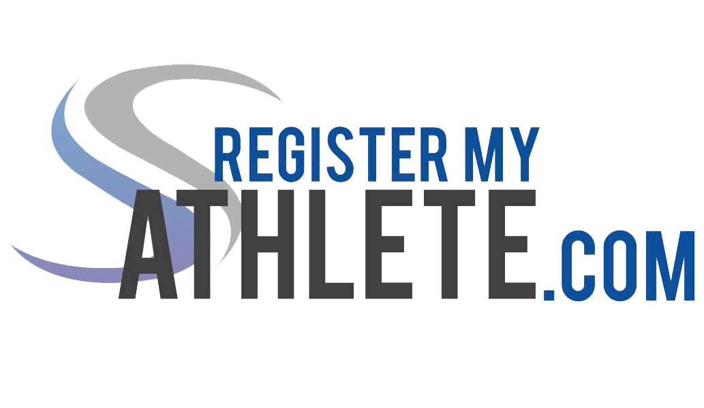**Instructions for Parents (Instrucciones para Padres)**

Register My Athlete allows parents to register their athletes for sports online. Here are some basic steps to follow when registering your athlete for the first time:

*(Registrar Mi Atleta (Register My Athlete) permite a los padres registrar a sus atletas para los deportes en línea. Aquí hay algunos pasos básicos a seguir cuando se registra su atleta por primera vez*

1. **Use Google Chrome, Firefox or Safari (iPhone).**
2. **Find Your School:** Find your school by going to <http://registermyathlete.com/schools/>, selecting your state, and finding your school. Click on the school to continue to the next step. Schools are encouraged to make a direct link from their school’s website.

***(Encuentre su escuela:*** *Encuentra su escuela yendo a* [*http://registermyathlete.com/schools/*](http://registermyathlete.com/schools/)*, seleccione su estado, y busque su escuela. Haga clic en su escuela para continuar con el siguiente paso. A las escuelas se les anima a hacer un enlace directo desde la página web de su escuela.)*

1. **Create an account:** Now begin creating your account by clicking the “Create an Account” button. After filing in the required information the system will automatically log you in and you will be required to accept the terms of use.

***(Crear una cuenta:*** *Ahora empiece a crear su cuenta haciendo clic en el botón "Crear una cuenta" (Create An Account). Después de completar la información requerida el sistema le dejara automáticamente iniciar la sesión y se le requerirá aceptar los términos de uso.)*

1. **Add a new athlete:** The next step is to add an athlete. You can do so by clicking the “My Athletes” tab on the left-hand side of the page or by clicking “Add Athlete” underneath the “My Athletes” tab. This only needs to be done once during your athlete’s entire career at a school. The information entered here will carry over from year to year. This information includes your athlete’s contact information and medical information.

***(Añadir un nuevo atleta:*** *El siguiente paso es añadir el atleta. Puede hacerlo haciendo clic en la pestaña "Mis atletas" (Mi Athletes) en el lado izquierdo de la página o por hacer clic en "Añadir Atleta" (Add Athlete) por debajo de la pestaña "Mis atletas" (My Athletes). Esto solo hay que hacerlo una sola vez durante toda la carrera de su atleta en una escuela. La información introducida aquí se trasladará de año en año. Esta información incluye la información de contacto de su atleta y la información médica.)*

1. **The athlete’s profile:** After you’ve created your athlete you will be brought to their Profile page. This page is a summary of their info and involvement.

***(El perfil del atleta:*** *Después de crear su atleta se le llevará a su página de perfil. Esta página es un resumen de su información y participación.)*

1. **Register for a sport:** Click “+ Register for a Sport” to begin registration, you will be asked to choose which sport your athlete is registering for.

***(Registrar para un deporte:*** *Haga clic en "+ Registro para un deporte" (+ Register for a Sport) para comenzar el registro, se le pedirá elegir para qué deporte su atleta está registrando.)*

1. **Your registration checklist:** This page shows the status of your athlete’s registration. You will be asked to complete several steps to complete registration including agreeing to documents, and completing the physical.

***(Lista de control para el registro:*** *Esta página muestra el estado de la registración de su atleta. Se le pedirá completar varios pasos para completar el registro incluso dar consentimiento a documentos, y completar el físico.)*

1. **Physicals:** Physical documents should be completed by the parents (or medical professionals as needed). Parents have the ability to upload these physical documents to the system. Uploaded documents will need to be verified by the admin at the school prior to be accepted as complete. (If a document upload is rejected for any reason, the parent will receive an email with the rejection reason. After the error has been corrected, parents will be able to re-upload the document for verification.)

***(El examen físico:*** *Documentos para el físico deben ser completados por los padres (o profesionales de la medicina, según sea necesario). Los padres tienen la posibilidad de cargar/subir (upload) estos documentos del físico al sistema. Los documentos cargados/subidos (uploaded) tendrán que ser verificados por el administrador de la escuela antes de ser aceptados como completos. (Si se rechaza una carga del documento por cualquier razón, el padre*

1. **Additional Athletes-** Under the same account, repeat step 3-9 to register additional athletes.